|  |
| --- |
|  |
| RELIABLE COMPUTER DISTRIBUTORS |
| Group Project |
|  |

GROUP MEMBERS :

AYLU RAO UIN : 650861257

HARI PRIYA POTHAM UIN : 652027199

SOUMYA KANDULA UIN : 658476080

SPURTHI GUDIGOPURAM UIN : 661017075

**Table of Contents**

Project Overview

Group Minutes

Task Assignment

Creation of Tables

1. Queries
2. Documenter Data
3. Relationship Documenter

Insertion of Data

1. Queries

Relationships in the Database

Forms

Reports

Switchboards

Assumptions

Security Plan

**PROJECT OVERVIEW**

The Reliable Computer Company is a distributor of computers and computer accessories to businesses. The aim is to create a database which operates efficiently and is easily maintainable by the company.

The entire database for Reliable Computer Company has been created in Microsoft Access.

**GROUP MINUTES**

|  |  |  |
| --- | --- | --- |
| DATE | TIME | DESCRIPTION |
| 11/19/15 |  | Base discussion about the project and overview. |
| 11/24/15 | 11:00 AM-12 PM | Task division to the individuals in the team. |
| 12/01/15 | 4:00 PM – 5PM | Task Review |
| 12/05/15 | 12:00 PM-12:30PM | Merging the Individual design |
| 12/06/15 | 2:00 PM-3PM | Final Discussion of the project |

ROLE/RESPONSIBILITY**:**

* Project work division among the group mates.
* Creation of tables, queries , forms and reports.
* Building the swtichboards .
* Making sure all the buttons are working or not .
* Over all review of the project.

**TASK ASSIGNMENT**

Creation of Tables : Aylu Rao

Data Insertion : Aylu Rao

Creation of Reports: Soumya Kandula

Creation of Forms: Soumya Kandula & Spurthi Gudigopuram

Documentation : Spurthi Gudigopuram

Creation of Switchboard and Sub Switchboards : Spurthi Gudigopuram

Test the Database: Hari Priya Potham

**Conceptual Design**

User view 6a:

Entity : Rep

Attributes : rep_no,rep_name,rep_addres,rep_no,rep_total_commission,commision_table.

Functional dependencies : rep_no🡪rep_name,rep_address,rep_no,rep_total_commision,commision_rate.

Primary key : rep_no.

Special Restriction : None .

DBDL : rep(rep_no , rep_name,rep_address,rep_no,rep_total_commision,commission_rate)

SK :rep_name.

Cumulative Design : rep(rep_no,rep_name,rep_address,rep_pno,rep_total_commision,commission_rate)

**User View 6b :**

Entity **:** Customer ,rep

Attributes : cust_no,cust_name,cust_address,cust_pno,contact_person,credit_limit,rep_no,

rep_no,rep_name.

Functional Dependencies :cust_no🡪cust_name,cust_address,cust_pno,contact_person,credit_limit

Rep_no🡪rep_name.

DBDL : Customer(cust_no,cust_name,cust_address,cust_pn0,contact_person,current_balance,credit_limit,rep_no,rep_name).

Decompose into 3NF :

Customer(cust_no , cust_name , cust_address,cust_p_no,contact_perso,current_balance,credit_limit,rep_no)

FK : rep_no🡪rep.

Sk :cust_name.

Rep(rep_no,rep_name)

Sk:rep_name .

Cumulative Designafter user view 6b:

Rep(rep_no,rep_name,rep_adrress,rep_pno,rep_total_commision,commission_rate)

SK:rep_name.

Customer(cust_no,cust_name,cust_address,cust_pno,contact_person,current_balance,credit_limit,rep_no).

FK:rep_no🡪rep.

SK :Cust_name.

The following is a duplicative from user view 6b so we delete

Rep(rep_no,rep_name)

SK:rep_name.

No special Restrictions .

User View 6c :

Entity : product

Attributes : p_no,m_no,m_name,p_descrip,model_no,price,cost,no of units,value.

Functional Dependency : p_no🡪m_no,m_name,p_descrip,model_no,price,cost,no units,value

PK:p_no

Special Restrictions none

DBDL : product (p_no,m_no,m_name,p_descrip,model_no,price,cost,no units,value)

Cumulative :rep(rep_no,,rep_name,rep_address,rep_no,rep_total_commision, rep_commision_rate)

SK rep_name

AK rep_no

Customer(cust_no,cust_name,cust_address,cust_pno,contact_person,current_balance,credit_limit,rep_no).

FK:rep_no🡪rep.

SK cust_name

Product(p_no,m_no,m_name,p_descrip,model_no,price,cost,no_units,value)

User View 7a :

Entity : product ,warehouse

Attributes : w_no,w_descrip,p_no,no units,p_descripo

Functional Dependency : w_no🡪w_descrip,p_no🡪p_descrip,no units .

PK:w_no

Special Restrictions none

DBDL : warehouse(w_no,w_descrip,p_no)

Product(p_no,p_descrp)

Cumulative:warehouse(w_no,w_decrp,p_no)

FK p_no🡪product

Product(p_no,m_no,m_name,p_descrip,model_no,price,cost,no_units,value)

The following is a duplicative from user view 7a so we delete

Product(p_no,p_descrrip)

No special restriction.

No Special restriction

User view 7b:

Entity : product_classi ,product

Attributes : classi_no,classi_descr ,p_no,p_descripo

Functional Dependency :classi_noàclassi_descrip,p_no,p_descrip .

PK:class_no

Special Restrictions none

DBDL :product_classi(classi_no,classi_descrip,p_no,p_descrip)

FK p_noàproduct

Product(p_no,p_descrip)

Cumulative design

Product_classi(classi_no,classi_descrip,p_no)

FK : p_noàproduct

Product(p_no, m_no, m_name, p_descrip, model_no, price, cost, no_units, value)

User View 7c:

Entity: Order, Customer

Attributes: o_no,o_date,cust_no, contact_person

Function Dependencies:

O_no 🡪O_date

Cust_no🡪contact_person

Primary Key: O_no

Special Restrictions: None

DBDL:

Order(O_no,O_date,Cust_no,Contact_person)

Decompose to 3NF:

Order(O_no,O_date,cust_no)

FK: Cust_no🡪 Customer

Customer(Cust_no, contact_person)

Cumulative after 7c:

Order(O_no,O_date,cust_no)

FK: Cust_no🡪 Customer

Customer(Cust_no, Cust_name, cust_address, cust_pno, contact_person, current_balance,credit_limit)

User View 7d:

Enitity: Rep, Cust

Attributes: Rep_no, rep_name, cust_no, cust_name, cust_address

Functional Dependencies:

Rep_no🡪rep_name

Cust_no🡪Cust_name,cust_address

Pk: rep_no

Special Restictions: None

DBDL:

Rep(rep_no, rep_name, cust_no, cust_name, cust_address)

Decompose to 3NF:

Rep(rep_no,rep_name, cust_no)

Customer(cust_no, cust_name, cust_address)

Cumulative design:

Rep(Rep_no, rep_name, rep_address, rep_pno, rep_total_comission,rep_comission_rate, cust_no)

Fk: Cust_no

Customer(Cust_no, cust_name, cust_address, cust_pno, contact_person, current_balance, credit_limit)

SalesRep(rep_no, rep_name,rep_address,rep_phone,rep_total_commission,rep_rate,cust_no)

FK: Cust_no

Customer(Cust_no, cust_name,cust_address,cust_phno,cust_contact,cust_balance,cust_credit)

Product(P_no, P_manu_no, m_name,P_descrip, model no, price, cost,no_units,values)

Warehouse(w_no, w_descrip,P_no)

Fk:P_no

Prod_classif(Class_no, class_description, P_no)

Fk: P_no

Order(O_no, O_date, Cust_no)

Fk: Cust_no

**DATASTRUCTURE DIAGRAM**

Warehouse

Product

Product Classification

Customer

Order

Rep

**CREATION OF TABLES**

**Customer :** SQL QUERY

create table Customer

(

Custid integer PRIMARY KEY,

Custname text(15),

Custstreet text(15),

Custcity text(15),

Custstate text(15),

Custzip integer,

CustPhone text(12),

ContFname text(15),

ContLname text(15),

Currbal double,

Credlim integer,

Repid integer,

CONSTRAINT fk_R_ID FOREIGN KEY (Repid) REFERENCES Salesrep(Repid)

)

Data Documenter

Friday, December 4, 2015

Table: Customer Page: 1

**Properties**

DateCreated: 11/23/2015 9:14:31 AM LastUpdated: 11/23/2015 10:30:31 AM

RecordCount: 0 Updatable: True

**Columns**

Name Type Size

Custid Long Integer 4

AllowZeroLength: False

AppendOnly: False

Attributes: Fixed Size

CollatingOrder: General

DataUpdatable: False

OrdinalPosition: 0

Required: False

SourceField: Custid

SourceTable: Customer

Custname Text 15

AllowZeroLength: False

AppendOnly: False

Attributes: Variable Length

CollatingOrder: General

DataUpdatable: False

OrdinalPosition: 1

Required: False

SourceField: Custname

SourceTable: Customer

Custstreet Text 15

AllowZeroLength: False

AppendOnly: False

Attributes: Variable Length

CollatingOrder: General

DataUpdatable: False

OrdinalPosition: 2

Required: False

SourceField: Custstreet

SourceTable: Customer

Custcity Text 15

AllowZeroLength: False

AppendOnly: False

Attributes: Variable Length

CollatingOrder: General

DataUpdatable: False

OrdinalPosition: 3

Required: False

SourceField: Custcity

SourceTable: Customer

Custstate Text 15

Friday, December 4, 2015

Table: Customer Page: 2

AllowZeroLength: False

AppendOnly: False

Attributes: Variable Length

CollatingOrder: General

DataUpdatable: False

OrdinalPosition: 4

Required: False

SourceField: Custstate

SourceTable: Customer

Custzip Long Integer 4

AllowZeroLength: False

AppendOnly: False

Attributes: Fixed Size

CollatingOrder: General

DataUpdatable: False

OrdinalPosition: 5

Required: False

SourceField: Custzip

SourceTable: Customer

CustPhone Text 12

AllowZeroLength: False

AppendOnly: False

Attributes: Variable Length

CollatingOrder: General

DataUpdatable: False

OrdinalPosition: 6

Required: False

SourceField: CustPhone

SourceTable: Customer

ContFname Text 15

AllowZeroLength: False

AppendOnly: False

Attributes: Variable Length

CollatingOrder: General

DataUpdatable: False

OrdinalPosition: 7

Required: False

SourceField: ContFname

SourceTable: Customer

ContLname Text 15

AllowZeroLength: False

AppendOnly: False

Attributes: Variable Length

CollatingOrder: General

DataUpdatable: False

OrdinalPosition: 8

Required: False

SourceField: ContLname

SourceTable: Customer

Currbal Double 8

Friday, December 4, 2015

Table: Customer Page: 3

AllowZeroLength: False

AppendOnly: False

Attributes: Fixed Size

CollatingOrder: General

DataUpdatable: False

OrdinalPosition: 9

Required: False

SourceField: Currbal

SourceTable: Customer

Credlim Long Integer 4

AllowZeroLength: False

AppendOnly: False

Attributes: Fixed Size

CollatingOrder: General

DataUpdatable: False

OrdinalPosition: 10

Required: False

SourceField: Credlim

SourceTable: Customer

Repid Long Integer 4

AllowZeroLength: False

AppendOnly: False

Attributes: Fixed Size

CollatingOrder: General

DataUpdatable: False

OrdinalPosition: 11

Required: False

SourceField: Repid

SourceTable: Customer

**Relationships**

**CustomerOrder**

**Customer** **Order**

Custid 1  Custid

Attributes: Enforced

RelationshipType: One-To-Many

**SalesrepCustomer**

**Salesrep** **Customer**

Repid 1  Repid

Attributes: Enforced

RelationshipType: One-To-Many

Friday, December 4, 2015

Table: Customer Page: 4

**Table Indexes**

Name Number of Fields

fk_R_ID 1

Clustered: False

DistinctCount: 0

Foreign: True

IgnoreNulls: False

Name: fk_R_ID

Primary: False

Required: False

Unique: False

Fields:

Repid Ascending

Index_E6E50120_79BE_4C9A 1

Clustered: False

DistinctCount: 0

Foreign: False

IgnoreNulls: False

Name: Index_E6E50120_79BE_4C9A

Primary: True

Required: True

Unique: True

Fields:

Custid Ascending

**User Permissions**

admin Delete, Read Permissions, Set Permissions, Change Owner, Read Definition,

Write Definition, Read Data, Insert Data, Update Data, Delete Data

**Group Permissions**

Admins Delete, Read Permissions, Set Permissions, Change Owner, Read Definition,

Write Definition, Read Data, Insert Data, Update Data, Delete Data

Users Delete, Read Permissions, Set Permissions, Change Owner, Read Definition,

Write Definition, Read Data, Insert Data, Update Data, Delete Data

**Salesrep :** SQL QUERY

create table Salesrep

(

Repid integer PRIMARY KEY,

Repname text(15),

Repstreet text(10),

Repcity text(10),

Repstate text(10),

Repzip integer,

RepPhone text(12),

Totcomm double,

Crate integer

)

Data Documenter

C:\Users\narsimha reddy\Downloads\Project Database (2).accdb Friday, December 4, 2015

Table: Salesrep Page: 1

**Properties**

DateCreated: 11/23/2015 8:59:09 AM LastUpdated: 11/23/2015 9:14:32 AM

RecordCount: 0 Updatable: True

**Columns**

Name Type Size

Repid Long Integer 4

AllowZeroLength: False

AppendOnly: False

Attributes: Fixed Size

CollatingOrder: General

DataUpdatable: False

OrdinalPosition: 0

Required: False

SourceField: Repid

SourceTable: Salesrep

Repname Text 15

AllowZeroLength: False

AppendOnly: False

Attributes: Variable Length

CollatingOrder: General

DataUpdatable: False

OrdinalPosition: 1

Required: False

SourceField: Repname

SourceTable: Salesrep

Repstreet Text 10

AllowZeroLength: False

AppendOnly: False

Attributes: Variable Length

CollatingOrder: General

DataUpdatable: False

OrdinalPosition: 2

Required: False

SourceField: Repstreet

SourceTable: Salesrep

Repcity Text 10

AllowZeroLength: False

AppendOnly: False

Attributes: Variable Length

CollatingOrder: General

DataUpdatable: False

OrdinalPosition: 3

Required: False

SourceField: Repcity

SourceTable: Salesrep

Repstate Text 10

AllowZeroLength: False

AppendOnly: False

Attributes: Variable Length

CollatingOrder: General

DataUpdatable: False

OrdinalPosition: 4

Required: False

SourceField: Repstate

SourceTable: Salesrep

Repzip Long Integer 4

AllowZeroLength: False

AppendOnly: False

Attributes: Fixed Size

CollatingOrder: General

DataUpdatable: False

OrdinalPosition: 5

Required: False

SourceField: Repzip

SourceTable: Salesrep

RepPhone Text 12

AllowZeroLength: False

AppendOnly: False

Attributes: Variable Length

CollatingOrder: General

DataUpdatable: False

OrdinalPosition: 6

Required: False

SourceField: RepPhone

SourceTable: Salesrep

Totcomm Double 8

AllowZeroLength: False

AppendOnly: False

Attributes: Fixed Size

CollatingOrder: General

DataUpdatable: False

OrdinalPosition: 7

Required: False

SourceField: Totcomm

SourceTable: Salesrep

Crate Long Integer 4

AllowZeroLength: False

AppendOnly: False

Attributes: Fixed Size

CollatingOrder: General

DataUpdatable: False

OrdinalPosition: 8

Required: False

SourceField: Crate

SourceTable: Salesrep

Friday, December 4, 2015

Table: Salesrep Page: 3

**Relationships**

**SalesrepCustomer**

**Salesrep** **Customer**

Repid 1  Repid

Attributes: Enforced

RelationshipType: One-To-Many

**Table Indexes**

Name Number of Fields

Index_F0A7952D_C552_40A9 1

Clustered: False

DistinctCount: 0

Foreign: False

IgnoreNulls: False

Name: Index_F0A7952D_C552_40A9

Primary: True

Required: True

Unique: True

Fields:

Repid Ascending

**User Permissions**

admin Delete, Read Permissions, Set Permissions, Change Owner, Read Definition,

Write Definition, Read Data, Insert Data, Update Data, Delete Data

**Group Permissions**

Admins Delete, Read Permissions, Set Permissions, Change Owner, Read Definition,

Write Definition, Read Data, Insert Data, Update Data, Delete Data

Users Delete, Read Permissions, Set Permissions, Change Owner, Read Definition,

Write Definition, Read Data, Insert Data, Update Data, Delete Data

**Product :** SQL QUERY

create table Product

(

Prodid text(8) PRIMARY KEY,

Manfid integer,

Manfname text(15),

Proddesc text(15),

Classid integer,

Modelnum text(6),

price double,

cost double,

TotnumOnHand integer,

OnHandValue integer,

CONSTRAINT fk_C_ID FOREIGN KEY (Classid) REFERENCES Classification(Classid),

CONSTRAINT fk_M_ID FOREIGN KEY (Manfid) REFERENCES Manufacturer(Manfid)

)

Data Documenter

Friday, December 4, 2015

Table: Product Page: 1

**Properties**

DateCreated: 11/23/2015 9:21:26 AM LastUpdated: 11/23/2015 10:32:01 AM

RecordCount: 0 Updatable: True

**Columns**

Name Type Size

Prodid Text 8

AllowZeroLength: False

AppendOnly: False

Attributes: Variable Length

CollatingOrder: General

DataUpdatable: False

OrdinalPosition: 0

Required: False

SourceField: Prodid

SourceTable: Product

Manfid Long Integer 4

AllowZeroLength: False

AppendOnly: False

Attributes: Fixed Size

CollatingOrder: General

DataUpdatable: False

OrdinalPosition: 1

Required: False

SourceField: Manfid

SourceTable: Product

Manfname Text 15

AllowZeroLength: False

AppendOnly: False

Attributes: Variable Length

CollatingOrder: General

DataUpdatable: False

OrdinalPosition: 2

Required: False

SourceField: Manfname

SourceTable: Product

Proddesc Text 15

AllowZeroLength: False

AppendOnly: False

Attributes: Variable Length

CollatingOrder: General

DataUpdatable: False

OrdinalPosition: 3

Required: False

SourceField: Proddesc

SourceTable: Product

Classid Long Integer 4

AllowZeroLength: False

AppendOnly: False

Attributes: Fixed Size

CollatingOrder: General

DataUpdatable: False

OrdinalPosition: 4

Required: False

SourceField: Classid

SourceTable: Product

Modelnum Text 6

AllowZeroLength: False

AppendOnly: False

Attributes: Variable Length

CollatingOrder: General

DataUpdatable: False

OrdinalPosition: 5

Required: False

SourceField: Modelnum

SourceTable: Product

price Double 8

AllowZeroLength: False

AppendOnly: False

Attributes: Fixed Size

CollatingOrder: General

DataUpdatable: False

OrdinalPosition: 6

Required: False

SourceField: price

SourceTable: Product

cost Double 8

AllowZeroLength: False

AppendOnly: False

Attributes: Fixed Size

CollatingOrder: General

DataUpdatable: False

OrdinalPosition: 7

Required: False

SourceField: cost

SourceTable: Product

TotnumOnHand Long Integer 4

AllowZeroLength: False

AppendOnly: False

Attributes: Fixed Size

CollatingOrder: General

DataUpdatable: False

OrdinalPosition: 8

Required: False

SourceField: TotnumOnHand

SourceTable: Product

OnHandValue Long Integer 4

AllowZeroLength: False

AppendOnly: False

Attributes: Fixed Size

CollatingOrder: General

DataUpdatable: False

OrdinalPosition: 9

Required: False

SourceField: OnHandValue

SourceTable: Product

**Relationships**

**ClassificationProduct**

**Classification** **Product**

Classid 1  Classid

Attributes: Enforced

RelationshipType: One-To-Many

**ManufacturerProduct**

**Manufacturer** **Product**

Manfid 1  Manfid

Attributes: Enforced

RelationshipType: One-To-Many

**ProductOrderline**

**Product** **Orderline**

Prodid 1  Prodid

Attributes: Enforced

RelationshipType: One-To-Many

**ProductWHprod**

**Product** **WHprod**

Prodid 1  Prodid

Attributes: Enforced

RelationshipType: One-To-Many

**Table Indexes**

Name Number of Fields

fk_C_ID 1

Clustered: False

DistinctCount: 0

Foreign: True

IgnoreNulls: False

Name: fk_C_ID

Primary: False

Required: False

Unique: False

Fields:

Classid Ascending

fk_M_ID 1

Clustered: False

DistinctCount: 0

Foreign: True

IgnoreNulls: False

Name: fk_M_ID

Primary: False

Required: False

Unique: False

Fields:

Manfid Ascending

Index_1DF3B9CF_08DB_4C70 1

Clustered: False

DistinctCount: 0

Foreign: False

IgnoreNulls: False

Name: Index_1DF3B9CF_08DB_4C70

Primary: True

Required: True

Unique: True

Fields:

Prodid Ascending

**User Permissions**

admin Delete, Read Permissions, Set Permissions, Change Owner, Read Definition,

Write Definition, Read Data, Insert Data, Update Data, Delete Data

**Classification :** SQL Query

create table Classification

(

Classid integer PRIMARY KEY,

Classdesc text(15)

)

Data Documenter

Table: Classification Page: 1

**Properties**

DateCreated: 11/23/2015 9:15:50 AM LastUpdated: 11/23/2015 9:21:26 AM

RecordCount: 0 Updatable: True

**Columns**

Name Type Size

Classid Long Integer 4

AllowZeroLength: False

AppendOnly: False

Attributes: Fixed Size

CollatingOrder: General

DataUpdatable: False

OrdinalPosition: 0

Required: False

SourceField: Classid

SourceTable: Classification

Classdesc Text 15

AllowZeroLength: False

AppendOnly: False

Attributes: Variable Length

CollatingOrder: General

DataUpdatable: False

OrdinalPosition: 1

Required: False

SourceField: Classdesc

SourceTable: Classification

**Relationships**

**ClassificationProduct**

**Classification** **Product**

Classid 1  Classid

Attributes: Enforced

RelationshipType: One-To-Many

**Table Indexes**

Name Number of Fields

Index_C0EE7347_9F4F_420F 1

Clustered: False

DistinctCount: 0

Foreign: False

IgnoreNulls: False

Name: Index_C0EE7347_9F4F_420F

Table: Classification

Primary: True

Required: True

Unique: True

Fields:

Classid Ascending

**User Permissions**

admin Delete, Read Permissions, Set Permissions, Change Owner, Read Definition,

Write Definition, Read Data, Insert Data, Update Data, Delete Data

**Group Permissions**

Admins Delete, Read Permissions, Set Permissions, Change Owner, Read Definition,

Write Definition, Read Data, Insert Data, Update Data, Delete Data

Users Delete, Read Permissions, Set Permissions, Change Owner, Read Definition,

Write Definition, Read Data, Insert Data, Update Data, Delete Data

**Manufacturer :** SQL Query

create table Manufacturer

(

Manfid integer PRIMARY KEY,

Manfname text(20)

)

Data Documenter

Friday, December 4, 2015

Table: Manufacturer Page: 1

**Properties**

DateCreated: 11/23/2015 9:18:42 AM LastUpdated: 11/23/2015 9:21:26 AM

RecordCount: 0 Updatable: True

**Columns**

Name Type Size

Manfid Long Integer 4

AllowZeroLength: False

AppendOnly: False

Attributes: Fixed Size

CollatingOrder: General

DataUpdatable: False

OrdinalPosition: 0

Required: False

SourceField: Manfid

SourceTable: Manufacturer

Manfname Text 20

AllowZeroLength: False

AppendOnly: False

Attributes: Variable Length

CollatingOrder: General

DataUpdatable: False

OrdinalPosition: 1

Required: False

SourceField: Manfname

SourceTable: Manufacturer

**Relationships**

**ManufacturerProduct**

**Manufacturer** **Product**

Manfid 1  Manfid

Attributes: Enforced

RelationshipType: One-To-Many

**Table Indexes**

Name Number of Fields

Index_25A7A85F_7AED_475F 1

Clustered: False

DistinctCount: 0

Foreign: False

IgnoreNulls: False

Name: Index_25A7A85F_7AED_475F

Primary: True

Required: True

Unique: True

Fields:

Manfid Ascending

**User Permissions**

admin Delete, Read Permissions, Set Permissions, Change Owner, Read Definition,

Write Definition, Read Data, Insert Data, Update Data, Delete Data

**Group Permissions**

Admins Delete, Read Permissions, Set Permissions, Change Owner, Read Definition,

Write Definition, Read Data, Insert Data, Update Data, Delete Data

Users Delete, Read Permissions, Set Permissions, Change Owner, Read Definition,

Write Definition, Read Data, Insert Data, Update Data, Delete Data

**Warehouse :** SQL Query

create table Warehouse

(

WHid integer PRIMARY KEY,

WHdesc text(20)

)

Data Documenter

C:\Users\narsimha reddy\Downloads\Project Database (2).accdb Friday, December 4, 2015

Table: Warehouse Page: 1

**Properties**

DateCreated: 11/23/2015 9:27:40 AM LastUpdated: 11/23/2015 10:22:55 AM

RecordCount: 0 Updatable: True

**Columns**

Name Type Size

WHid Long Integer 4

AllowZeroLength: False

AppendOnly: False

Attributes: Fixed Size

CollatingOrder: General

DataUpdatable: False

OrdinalPosition: 0

Required: False

SourceField: WHid

SourceTable: Warehouse

WHdesc Text 20

AllowZeroLength: False

AppendOnly: False

Attributes: Variable Length

CollatingOrder: General

DataUpdatable: False

OrdinalPosition: 1

Required: False

SourceField: WHdesc

SourceTable: Warehouse

**Relationships**

**WarehouseWHprod**

**Warehouse** **WHprod**

WHid 1  WHid

Attributes: Enforced

RelationshipType: One-To-Many

**Table Indexes**

Name Number of Fields

Index_B34664B2_8FBE_4A22 1

Clustered: False

DistinctCount: 0

Foreign: False

IgnoreNulls: False

Name: Index_B34664B2_8FBE_4A22

Primary: True

Required: True

Unique: True

Fields:

WHid Ascending

**User Permissions**

admin Delete, Read Permissions, Set Permissions, Change Owner, Read Definition,

Write Definition, Read Data, Insert Data, Update Data, Delete Data

**Group Permissions**

Admins Delete, Read Permissions, Set Permissions, Change Owner, Read Definition,

Write Definition, Read Data, Insert Data, Update Data, Delete Data

Users Delete, Read Permissions, Set Permissions, Change Owner, Read Definition,

Write Definition, Read Data, Insert Data, Update Data, Delete Data

**WHprod :** SQL Query

create table WHprod

(

WHid integer,

Prodid text(8),

NumUnits integer,

CONSTRAINT fk_W_ID FOREIGN KEY (WHid) REFERENCES Warehouse(WHid),

CONSTRAINT fk_P_ID FOREIGN KEY (Prodid) REFERENCES Product(Prodid)

)

Data Documenter

Friday, December 4, 2015

Table: WHprod Page: 1

**Properties**

DateCreated: 11/23/2015 10:22:55 AM LastUpdated: 11/23/2015 10:22:55 AM

RecordCount: 0 Updatable: True

**Columns**

Name Type Size

WHid Long Integer 4

AllowZeroLength: False

AppendOnly: False

Attributes: Fixed Size

CollatingOrder: General

DataUpdatable: False

OrdinalPosition: 0

Required: False

SourceField: WHid

SourceTable: WHprod

Prodid Text 8

AllowZeroLength: False

AppendOnly: False

Attributes: Variable Length

CollatingOrder: General

DataUpdatable: False

OrdinalPosition: 1

Required: False

SourceField: Prodid

SourceTable: WHprod

NumUnits Long Integer 4

AllowZeroLength: False

AppendOnly: False

Attributes: Fixed Size

CollatingOrder: General

DataUpdatable: False

OrdinalPosition: 2

Required: False

SourceField: NumUnits

SourceTable: WHprod

**Relationships**

**ProductWHprod**

**Product** **WHprod**

Prodid 1  Prodid

Attributes: Enforced

RelationshipType: One-To-Many

**WarehouseWHprod**

**Warehouse** **WHprod**

WHid 1  WHid

Attributes: Enforced

RelationshipType: One-To-Many

**Table Indexes**

Name Number of Fields

fk_P_ID 1

Clustered: False

DistinctCount: 0

Foreign: True

IgnoreNulls: False

Name: fk_P_ID

Primary: False

Required: False

Unique: False

Fields:

Prodid Ascending

fk_W_ID 1

Clustered: False

DistinctCount: 0

Foreign: True

IgnoreNulls: False

Name: fk_W_ID

Primary: False

Required: False

Unique: False

Fields:

WHid Ascending

**Order :** SQL Query

create table Order

(

Orderid integer PRIMARY KEY,

Orderdate date,

Custid integer,

CONSTRAINT fk_Cu_ID FOREIGN KEY (Custid) REFERENCES Customer(Custid)

)

Data Documenter

C:\Users\narsimha reddy\Downloads\Project Database (2).accdb Friday, December 4, 2015

Table: Order Page: 1

**Properties**

DateCreated: 11/23/2015 10:30:31 AM LastUpdated: 11/23/2015 10:32:01 AM

RecordCount: 0 Updatable: True

**Columns**

Name Type Size

Orderid Long Integer 4

AllowZeroLength: False

AppendOnly: False

Attributes: Fixed Size

CollatingOrder: General

DataUpdatable: False

OrdinalPosition: 0

Required: False

SourceField: Orderid

SourceTable: Order

Orderdate Date/Time 8

AllowZeroLength: False

AppendOnly: False

Attributes: Fixed Size

CollatingOrder: General

DataUpdatable: False

OrdinalPosition: 1

Required: False

SourceField: Orderdate

SourceTable: Order

Custid Long Integer 4

AllowZeroLength: False

AppendOnly: False

Attributes: Fixed Size

CollatingOrder: General

DataUpdatable: False

OrdinalPosition: 2

Required: False

SourceField: Custid

SourceTable: Order

**Relationships**

**CustomerOrder**

**Customer** **Order**

Custid 1  Custid

Attributes: Enforced

RelationshipType: One-To-Many

**OrderOrderline**

**Order** **Orderline**

Orderid 1  Orderid

Attributes: Enforced

RelationshipType: One-To-Many

**Table Indexes**

Name Number of Fields

fk_Cu_ID 1

Clustered: False

DistinctCount: 0

Foreign: True

IgnoreNulls: False

Name: fk_Cu_ID

Primary: False

Required: False

Unique: False

Fields:

Custid Ascending

Index_739E9D0A_D3D4_45B5 1

Clustered: False

DistinctCount: 0

Foreign: False

IgnoreNulls: False

Name: Index_739E9D0A_D3D4_45B5

Primary: True

Required: True

Unique: True

Fields:

Orderid Ascending

**Orderline :** SQL Query

create table Orderline

(

Orderid integer,

Prodid text(8),

NumOrdered integer,

Quoteprice double,

CONSTRAINT fk_Ol_ID FOREIGN KEY (Orderid) REFERENCES Order(Orderid),

CONSTRAINT fk_Or_ID FOREIGN KEY (Prodid) REFERENCES Product(Prodid)

)

Data Documenter

Friday, December 4, 2015

Table: Orderline Page: 1

**Properties**

DateCreated: 11/23/2015 10:32:01 AM LastUpdated: 11/23/2015 10:32:01 AM

RecordCount: 0 Updatable: True

**Columns**

Name Type Size

Orderid Long Integer 4

AllowZeroLength: False

AppendOnly: False

Attributes: Fixed Size

CollatingOrder: General

DataUpdatable: False

OrdinalPosition: 0

Required: False

SourceField: Orderid

SourceTable: Orderline

Prodid Text 8

AllowZeroLength: False

AppendOnly: False

Attributes: Variable Length

CollatingOrder: General

DataUpdatable: False

OrdinalPosition: 1

Required: False

SourceField: Prodid

SourceTable: Orderline

NumOrdered Long Integer 4

AllowZeroLength: False

AppendOnly: False

Attributes: Fixed Size

CollatingOrder: General

DataUpdatable: False

OrdinalPosition: 2

Required: False

SourceField: NumOrdered

SourceTable: Orderline

Quoteprice Double 8

AllowZeroLength: False

AppendOnly: False

Attributes: Fixed Size

CollatingOrder: General

DataUpdatable: False

OrdinalPosition: 3

Required: False

SourceField: Quoteprice

SourceTable: Orderline

**Relationships**

**OrderOrderline**

**Order** **Orderline**

Orderid 1  Orderid

Attributes: Enforced

RelationshipType: One-To-Many

**ProductOrderline**

**Product** **Orderline**

Prodid 1  Prodid

Attributes: Enforced

RelationshipType: One-To-Many

**Table Indexes**

Name Number of Fields

fk_Ol_ID 1

Clustered: False

DistinctCount: 0

Foreign: True

IgnoreNulls: False

Name: fk_Ol_ID

Primary: False

Required: False

Unique: False

Fields:

Orderid Ascending

fk_Or_ID 1

Clustered: False

DistinctCount: 0

Foreign: True

IgnoreNulls: False

Name: fk_Or_ID

Primary: False

Required: False

Unique: False

Fields:

**RELATIONSHIPS**

Friday, December 4, 2015

Relationships: All Page: 5

**Relationships**

**ClassificationProduct**

**Classification** **Product**

Classid 1  Classid

Attributes: Enforced

RelationshipType: One-To-Many

**CustomerOrder**

**Customer** **Order**

Custid 1  Custid

Attributes: Enforced

RelationshipType: One-To-Many

**ManufacturerProduct**

**Manufacturer** **Product**

Manfid 1  Manfid

Attributes: Enforced

RelationshipType: One-To-Many

**OrderOrderline**

**Order** **Orderline**

Orderid 1  Orderid

Attributes: Enforced

RelationshipType: One-To-Many

**ProductOrderline**

**Product** **Orderline**

Prodid 1  Prodid

Attributes: Enforced

RelationshipType: One-To-Many

C:\Users\narsimha reddy\Downloads\Project Database (2).accdb Friday, December 4, 2015

Relationships: All Page: 6

**ProductWHprod**

**Product** **WHprod**

Prodid 1  Prodid

Attributes: Enforced

RelationshipType: One-To-Many

**SalesrepCustomer**

**Salesrep** **Customer**

Repid 1  Repid

Attributes: Enforced

RelationshipType: One-To-Many

**WarehouseWHprod**

**Warehouse** **WHprod**

WHid 1  WHid

Attributes: Enforced

RelationshipType: One-To-Many

**Insertion of Data**

CLASSIFICATION TABLE

insert into classification values(10, "Laptop");

insert into classification values(11, "Desktop");

insert into classification values(12, "Tablet");

insert into classification values(13, "Monitors");

insert into classification values(14, "Keyboards");

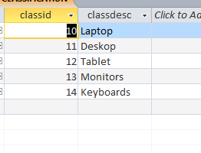

CUSTOMER TABLE

Insert into Customer values(100,"Abby","Sequoia","Ridgewood","Ct",56565,7321657809,"Abby","John", 54445,1200,3);

Insert into Customer values(101,"Ace","Raymond","Lakewood","De",56664,6353523422,"Ace","Hall",78788 ,750,5);

Insert into Customer values(102,"Zach","Steeple","Stonewall","Ak",60563,8980933452 ,"Zach","Young",13323.98 ,1500,1);

Insert into Customer values(103,"Grey","Amersale","Highlands","Al",89941,9102559011, "Grey", "Taylor", 787.25 ,500,4);

Insert into Customer values(104,"Agatha ","Winding River","Meadows","In",42234,976873352,"Agatha","Adams", 787, 1000,3);

MANUFACTURER TABLE

Insert into manufacturer values(913, "Sitecom");

Insert into manufacturer values(987, "Tp-Link");

Insert into manufacturer values(1082, "Omron");

Insert into manufacturer values(4356, "Ulsi");

Insert into manufacturer values(6012, "D-Max");

ORDER TABLE

Insert into order values(21,12/12/1201,100);

Insert into orderline values(10, "abc",2,967);

Insert into orderline values(11, "abc",2,500);

Insert into orderline values(11,"efg",5,257);

Insert into orderline values(12,"pqr",1,150);

Insert into orderline values(13, "xyz",7,750);

PRODUCT TABLE

Insert into product values("abc",1082,"tiyy",12,"kukrt",598,500,2,1000);

Insert into product values("Button",6012,"keyboard",13,"gfg",233,545,3,545);

Insert into product values("efg",6012,"jcjf",14,"xkajh",1233,1000,4,4000);

Insert into product values("jkl",913,"trifo",11,"offggorr",8989,8000,3,24000);

SALESREP TABLE

Insert into salesrep values(1,"John","Rand","Warrenville","Il",60009,2177893426,100.67,5);

Insert into salesrep values(2,"Smith","Diehl","Kingwood","Tx",60563,7320988334,655,2);

Insert into salesrep values(3,"July","Greenwood","Mt prospects","Ca",71257,4330183463,321.3,10);

Insert into salesrep values(4,"Emy","Eola","Wheeling","Mo",82615,9816325934,1539.9,15);

WAREHOUSE TABLE

insert into warehouse values(50,"hfnn");

insert into warehouse values(51,"yer");

insert into warehouse values(52,"vxcsv");

insert into warehouse values(53,"tsrdt");

WHPROD TABLE

insert into whprod values(50,"abc",675);

insert into whprod values(51,"pqr",190);

insert into whprod values(52,"jkl",35);

insert into whprod values(53,"xyz",20);

**The Relationships in the Database**

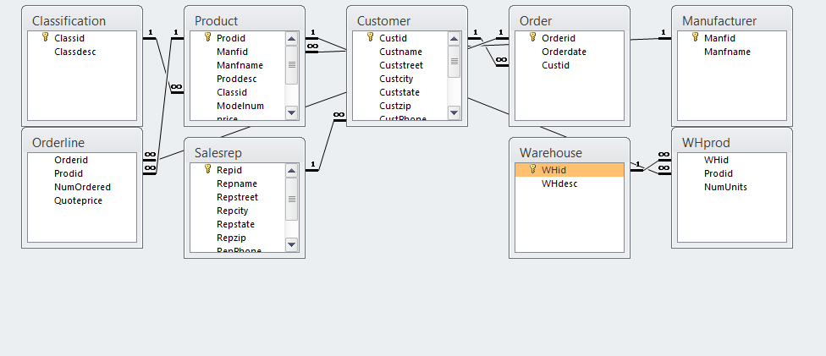

**FORMS**

Form is used to perform the data entry in a database. By using forms we can insert, update,delete the data in the database.

For the Reliable Computer System Database we created three forms Customer form, order form , product form.

Some differentiable features in these forms:

Let us start with the Customer Form, in the customer form we have a text field for the salesrep id. As we know the salesrep id is a foreign key and when we add a value for the salesrep id that is not present in the sales rep table, the system creates the idno and the other attributes in the sales rep table for the sales rep are empty.To make changes we have to go back to the sales rep table and make changes. To avoid this sort of problems we added a drop down box, which has the values of salesrep id that are already present in the salesrep table. This is also the case with the order and product form where the foreign key attributes have dropdown boxes .

CUSTOMER FORM

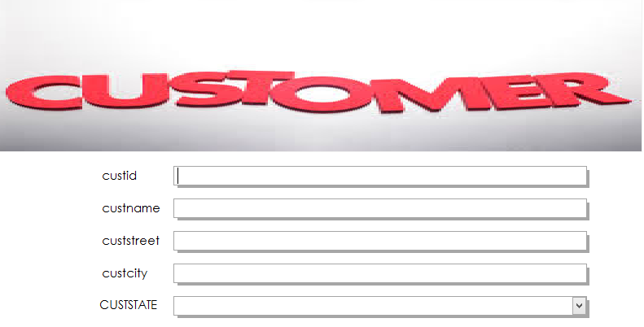

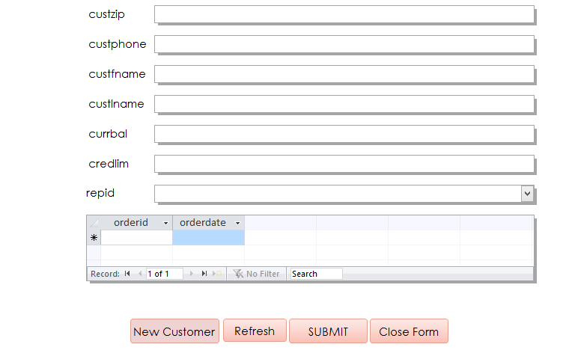

ORDER FORM

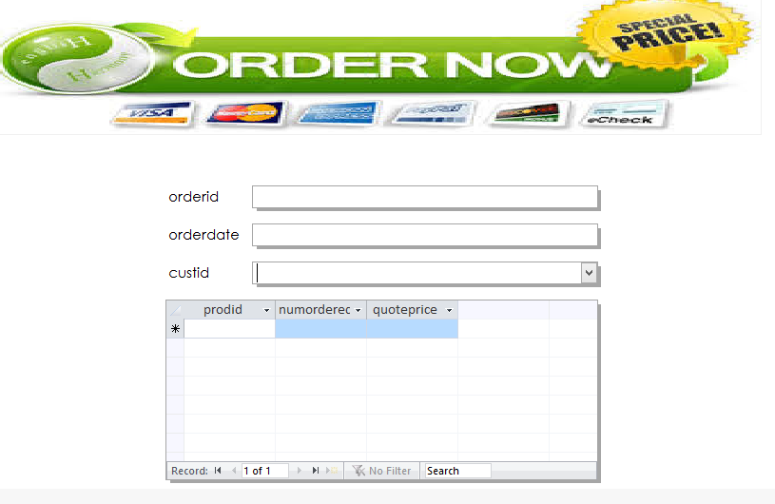 PRODUCT FORM

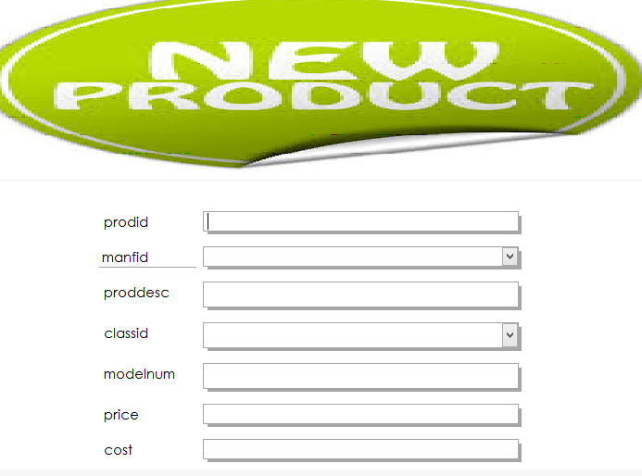

CUSTOMER SEARCH FORM

Another form we created is a search form which is used to search the customer information. When a customer’s first name, last name or custid ; then the customer details are fetched.

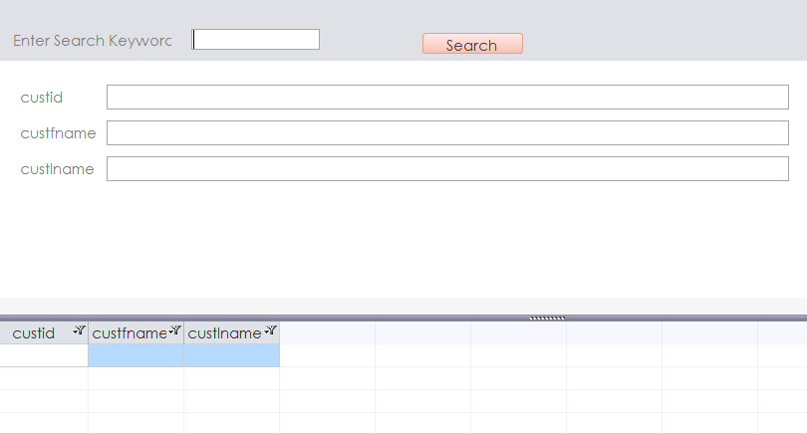

**REPORTS**

Reports are used to view the data in the database and also print them.

Customer Report

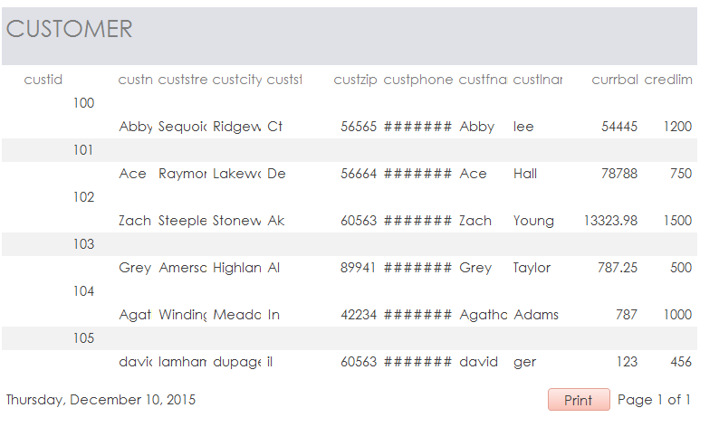

Order Report

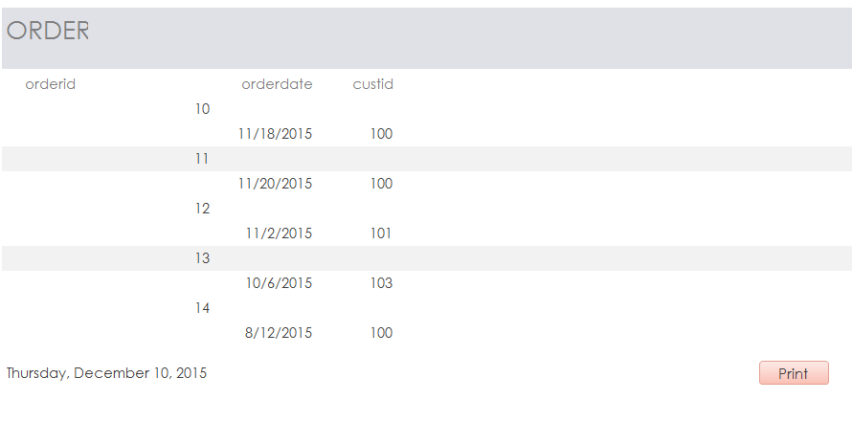

PRODUCT REPORT

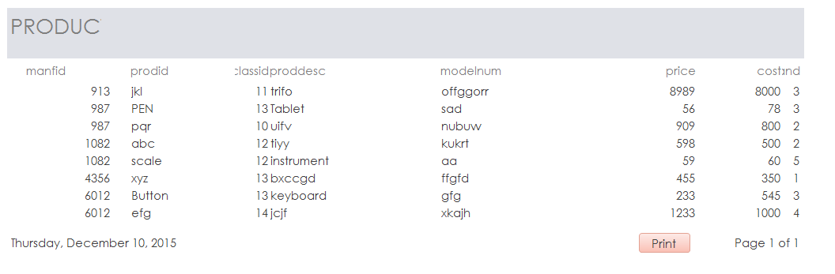

**SWITCH BOARD**

A switchboard is created for navigation in a database.

* For the Reliable Computer Systems there were many forms, reports and tables created. All the forms, reports are for products, order and customer so we made the main switchboard with customer menu, order menu, product menu.
* There is a main switchboard and 3 sub switchboards for the database.
* The main switchboard is made up of toggle buttons that are linked to labels as seen in the diagram below.

MAIN SWITCHBOARD

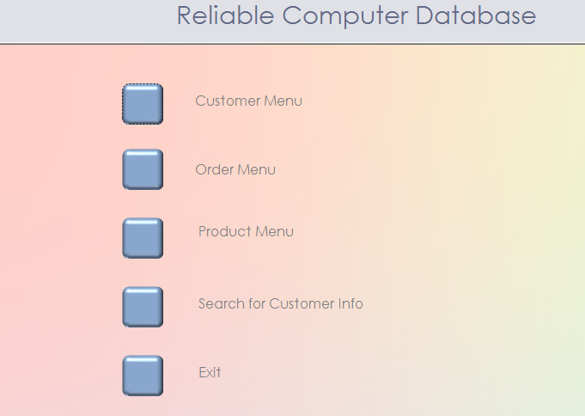

SUB SWITCHBOARD

* The Customer Menu, Order Menu and the Product Menu are the three sub switchboards in the database.
* The three sub switchboards have been made with the help of buttons and the navigation control.
* The sub switchboards have the functionality to navigate to the other sub switchboards and the main switchboard.
* There are 2 exit options given in the subswitchboard; one to exit the current switchboard that the user is viewing and the other directly to close Access from the respective sub switchboard.

CUSTOMER MENU

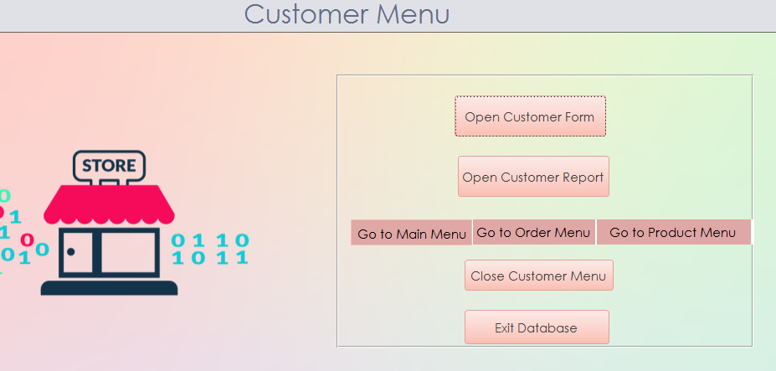

ORDER MENU

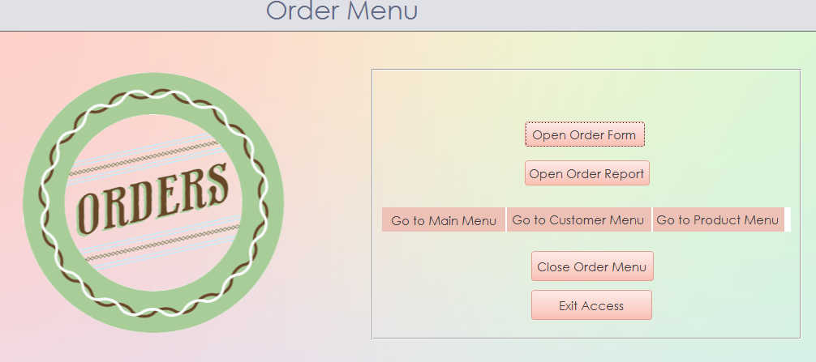

PRODUCT MENU

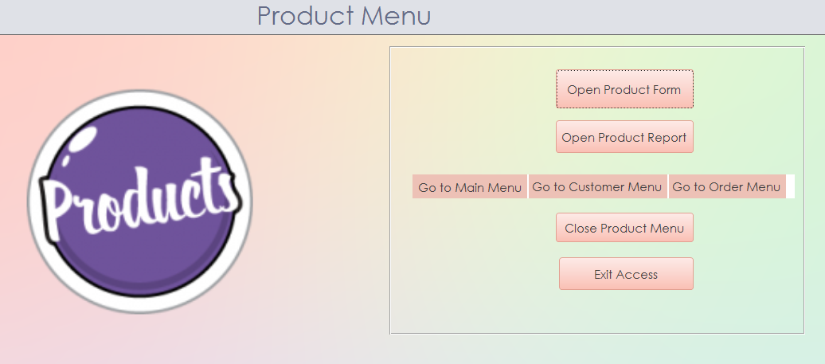

**ASSUMPTIONS**

IN CUSTOMER PERSPECTIVE : Customer does not need customer id in the form , we need to auto populate it but being it as an primary key we are not able to do that

**SECURITY PLAN**

Our group assumption for putting forward login form for salesrep is not all the representatives gets access to the customer data . The thought process is that salesrep gives his credentials to enter into the database and based upon his designation it decides what amount of data he can retrieve or look at it . we just created login form with credentials and its not fully functional with designation part .